Grand Representative Sash Guidelines

- We will be working on these sashes at the Grand Representative Retreat so be prepared to bring any items you want to attach. (I will have some things and paints)
- All decorations must be on the BACK of the sash and should be Rainbow appropriate.
- Your sash should represent your appointed state or country. Decorate it with symbols, mascots, sport teams or points of interest about your state or country.
- Be creative, use different types of materials, stickers, pictures, flowers.
- No use of black or dark colors, with the exception of printed decor like stickers or pictures. The use of bright Rainbow colors would be ideal.
- Glitter cannot be used. We do not want to ruin your dress. Puffy paint is permitted.
- Make sure you are able to sit comfortably while wearing your sash with the decorations.
- Do not attach 3D objects that will weigh down the sash. Items need to be light in weight so it will not pull on your dress.

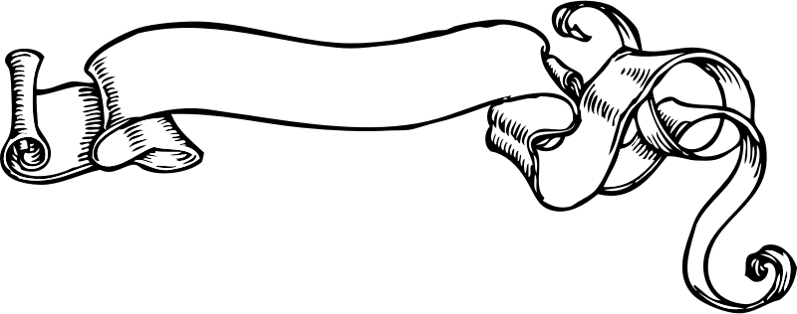
Be creative !

